**20200929 Homework**

1. **Distance of discrete random variables.**

Prove that $max⁡\{H\left(X | Y\right), H(Y|X)\}$ is a distances of discrete random variables *X* and *Y*.

令 $ρ\left(X,Y\right)=max⁡\{H\left(X | Y\right), H(Y|X)\}$

1. $ρ\left(X,Y\right)≥0$ since H(X|Y) >= 0 and H(Y|X)>=0 always hold.
2. $ρ\left(X,Y\right)=ρ\left(Y,X\right)$. $\max\left\{H\left(X | Y\right), H\left(Y | X\right)\right\}=\max\left\{H\left(Y | X\right), H\left(X | Y\right)\right\}$
3. H(X|Y) >= 0 and H(Y|X)>=0. If we say X=Y if there is a one-to-one mapping from X to Y, H(Y|X)=H(X|Y)=0 holds.
4. $ρ\left(X,Y\right)=max⁡\{H\left(X|Y\right),H(Y|X)\}$, $ρ\left(Y,Z\right)=max⁡\{H\left(Y|Z\right),H(Z|Y)\}$, $ρ\left(X,Z\right)=max⁡\{H\left(X|Z\right),H(Z|X)\}$,

$$H\left(X | Z\right)=H\left(X | Z,Y\right)+I\left(X;Y | Z\right)≤H\left(X | Y\right)+H(Y|Z)$$

$$H\left(Z | X\right)=H\left(Z | X,Y\right)+I\left(Z;Y | X\right)≤H\left(Z | Y\right)+H(Y|X)$$

By definition, we have $ρ\left(X,Y\right)≥H(X|Y)$, $ρ\left(X,Y\right)≥H(Y|X)$ and $ρ\left(Y,Z\right)≥H(Y|Z)$, $ρ\left(Y,Z\right)≥H(Z|Y)$. So $ρ\left(X,Y\right)+ρ\left(Y,Z\right)≥ ρ\left(X,Z\right)$.

**2. Prove the following two chain rules.**

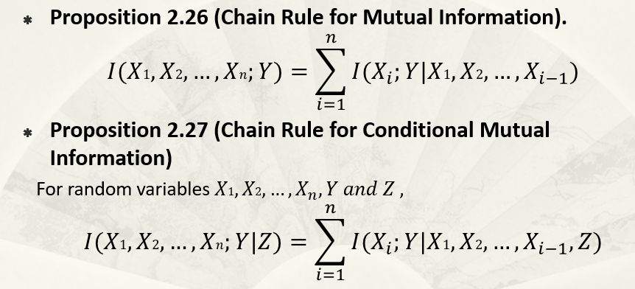

$$I\left(X_{1},X_{2},…,X_{n};Y\right)=H\left(X_{1},X_{2},…,X_{n}\right)-H\left(X_{1},X_{2},…,X_{n}|Y\right)=\sum_{i=1}^{n}{H\left(X_{i} | X_{i-1},…,X_{1}\right)-H\left(X_{i} | X_{i-1},…,X_{1},Y\right)=\sum_{i=1}^{n}{I(X_{i};Y|X_{1},…X_{i-1})}}$$

**条件互信息同理**

**3. Log-Sum inequality**: For non-negative numbers $a_{i}$ and $b_{i}$, prove

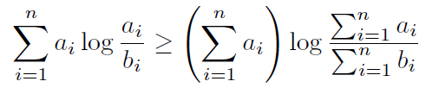.

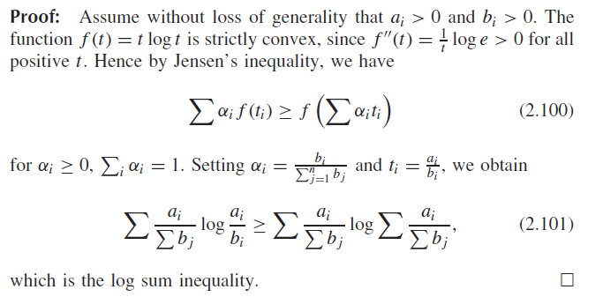

**4. Convex Relative Entropy**

If $(p_{1},q_{1})$ and $(p_{2},q_{2})$ are pairs of probability mass functions then



for all $0≤λ≤1$. That is, $D(p||q)$ is **convex function** of the pair $(p,q)$.

For any fixed x, applying log sum inequality yields

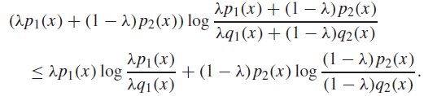

Summing over all x, the proof is completed.

**5. Concave Entropy**

Let $p$ be the probability mass function of discrete random variable *X*. Here $H(X)$ is denoted by $H(p)$. Prove that



That is, $H(p)$ is a **concave function** of $p$.

Let $u$ be the uniform distribution on alphabet $X$.

$$H\left(p\right)+D(p|\left|u\right)=\sum_{x}{p\left(x\right)\log{\frac{1}{p\left(x\right)}}}+\sum_{x}{p\left(x\right)\log{\frac{p\left(x\right)}{u\left(x\right)}}}=\sum_{x}{p\left(x\right)\log{\frac{1}{\frac{1}{\left|X\right|}}}}=\log{|X|}$$

So $H\left(p\right)=\log\left|X\right|-D(p||u).$ The concavity of H then follows directly from the convexity of D.

另一种做法

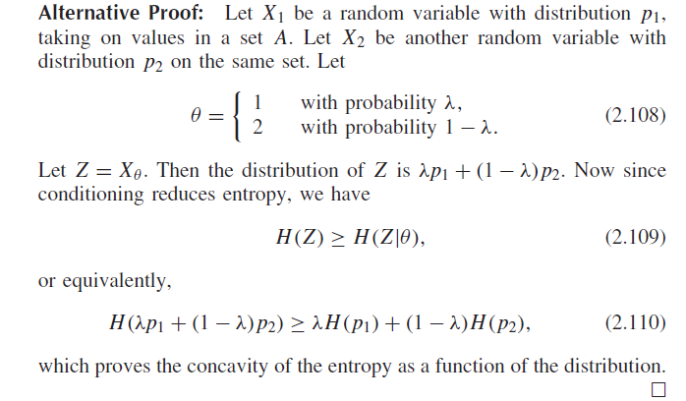

**6. Prove the Fano’s inequality.**

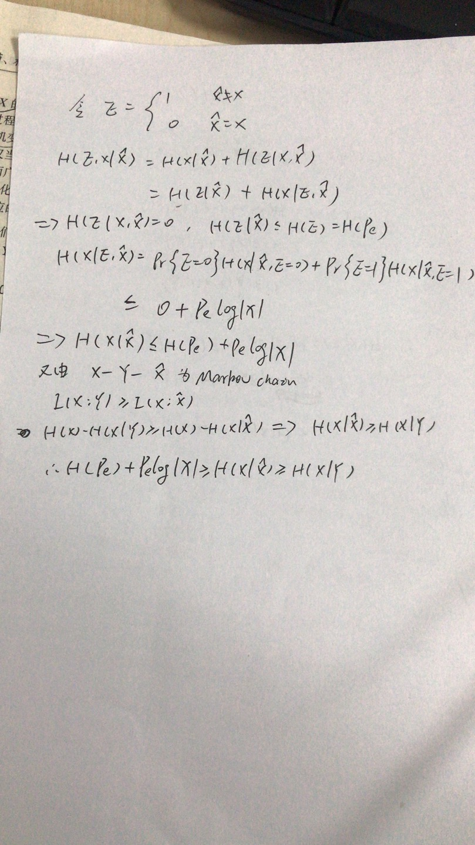

**7.** If $X_{1}→X_{2}→X_{3}→X_{4}→X_{5}→X_{6}$ is a Markov chain, **judge and show** whether $(X_{3},X_{6})→(X_{2},X_{5})→(X_{1},X_{4})$ is also a Markov chain.

1) When =0， is also a Markov chain.

2）Otherwise, it is not a Markov chain.

**8. Remark. Convex and Concave mutual information**

Mutual Information $I(X;Y)$ can be expressed by a function of input distribution $p(x)$ and transition distribution $p(y|x)$, i.e.,

$I\left(X;Y\right)=f(p\left(x\right),p(y|x))$.

1. For given input distribution $p(x)$, we say that $I\left(X;Y\right)$ is **convex** of transition distribution $p(y|x)$.
2. For given transition distribution $p(y|x)$, we say that $I\left(X;Y\right)$ is **concave** of input distribution $p(x)$.

**Convex 8A can be explained by:**

Let $p_{1}\left(x,y\right)=p(x)p_{1}\left(y|x\right)$ and $p_{2}\left(x,y\right)=p(x)p_{2}\left(y|x\right)$ be two joint distributions, we define

$p\left(x,y\right)≜λp_{1}\left(x,y\right)+\left(1-λ\right)p_{2}\left(x,y\right)=λp\left(x\right)p_{1}\left(y|x\right)+\left(1-λ\right)p\left(x\right)p_{2}\left(y|x\right)=p(x)\left\{λp_{1}\left(y|x\right)+\left(1-λ\right)p_{2}\left(y|x\right)\right\}$

$q\left(x,y\right)≜λq_{1}\left(x,y\right)+\left(1-λ\right)q_{2}\left(x,y\right)≜λp\left(x\right)p_{1}\left(y\right)+\left(1-λ\right)p\left(x\right)p_{2}\left(y\right)=p\left(x\right)\left\{λp_{1}\left(y\right)+\left(1-λ\right)p_{2}\left(y\right)\right\}$

$I_{λ}(X;Y)≜D(p\left(x,y\right)||q\left(x,y\right))$

$I_{1}(X;Y)≜D(p_{1}\left(x,y\right)||q_{1}\left(x,y\right))=D(p_{1}\left(x,y\right)||{p\left(x\right)p}_{1}\left(y\right))$

$I_{2}(X;Y)≜D(p_{2}\left(x,y\right)||q_{2}\left(x,y\right))=D(p_{2}\left(x,y\right)||{p\left(x\right)p}_{2}\left(y\right))$

**Then, for given input distribution $p(x)$, $I\left(X;Y\right)$ is convex of transition distribution $p(y|x)$, i.e.,**

$I_{λ}\left(X;Y\right)≤λI_{1}\left(X;Y\right)+(1-λ)I_{2}(X;Y)$**i.e.**

$$D(p\left(x,y\right)||q\left(x,y\right))≤λD(p_{1}\left(x,y\right)||q_{1}\left(x,y\right))+(1-λ)D(p_{2}\left(x,y\right)||q_{2}\left(x,y\right))$$